1. a specification of the work to be performed (definition of the game or optimization problem to be solved)

2 player game on a 6×6 board with 1×4 extensions on each side

Stacks may move as many spaces as there are pieces in the stack

Players can move a stack orthogonally, and if their piece is on top of the stack

The game ends when a player doesn’t have any piece on top of any stack

Each stack, of 5 pieces maximum, when landing on another stack, the stacks merge. if the new stack contains more than five pieces, then pieces are removed from the bottom to bring it down to five. If a player's own piece is removed, they are kept outside the board to use later, if the piece is of the opponent, they are removed

A player doesn’t need to move the complete stack. But if he doesn’t, he must only take as many pieces of the same as positions moved

1. related work with references to works found in a bibliographic search (articles, web pages, and/or source code)

<https://boardgamegeek.com/boardgame/789/focus>

<https://boardgamegeek.com/video/477999/focus/domination-focus-sid-sackson-classic-sdj-1981>

<https://en.wikipedia.org/wiki/Focus_(board_game)>

1. 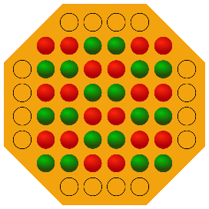formulation of the problem as a search problem (state representation, initial state, objective test, operators (names, preconditions, effects, and costs), heuristics/evaluation function) or optimization problem (solution representation, neighborhood/mutation and crossover functions, hard constraints, evaluation functions)

initial state:

objective test: check if board is in final state

Final state: the top piece of every stack still on the board belongs to the same player, thus declaring victory to that player

Operators: move stack (up, down, left or right)

Preconditions: can move as many positions as pieces on the stack and only moves if the top piece is theirs

Effects: ??

Costs: do we have costs??

Heuristic: minimax with alpha beta cuts

1. implementation work already carried out (programming language, development environment, data structures, among others)

programming language: Python

development environment: visual studio code

data structures: nested lists

possible framework for visualization: pygames